List of electronic and medical devices
of JSC “INTEGRAL”-“INTEGRAL” Holding Managing Company

Product name | Accessories for 1 product | Price (EXW)  per 1 piece,  USD
ESU INTEGRAL electrosurgical unit  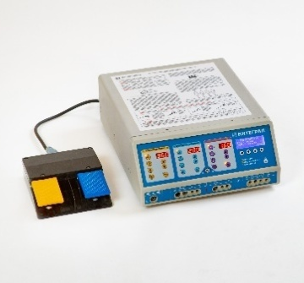  FEACN 9018 90 840 9 | - silicone neutral electrode, reusable, for adults – 1 pc;  - cable for reusable silicone neutral electrodes, length not less than 3 m – 1 pc;  - 4 mm electrode holder, 2-button,  - 3-pin connector, cable not less than 3 m – 1 pc;  - straight knife electrode, 4 mm mounting connector – 5 pcs;  - straight ball electrode, 2mm, 4 mm mounting connector – 5 pcs;  - straight needle electrode, 0.5 mm, 4 mm mounting connector - 5 pcs;  - bipolar cable, length not less than 3 m - 1 pc;  - straight tweezers, 1 mm, 195 mm long – 1 pc. | from 5460,00
Portable emergency ventilator  FEACN 9019 20 000 0  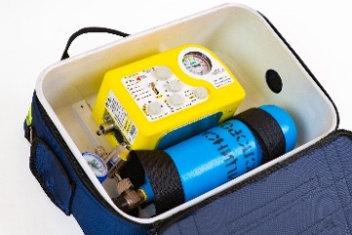 | - 12 V battery, 1.3 A/h – 1 pc;  - network adapter – 1 pc;  - 12 V power cord – 1 pc;  - high-pressure hose - 1 pc;  - working gas supply hose - 1 pc;  - 2 liter cylinder for medical oxygen– 1 pc;  - oxygen reducer – 1 pc;  - reusable patient contour with exhalation valve – 1 pc;  - S2T bag – 1 pc. | from 3890,00
INTEGRAL 12 patient monitor  FEACN 9018 19 900 0  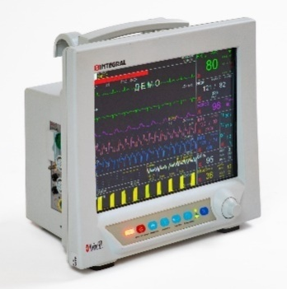 | - disposable ECG electrodes – 50 pcs;  - patient five-wire ECG cable - 1 pc;  - pulse oximetry sensors to an extension cord for adults – 1 pc;  - extension cord to a pulse oximetry sensor – 1 pc;  - reusable NIBP cuffs for adults – 2 pcs;  - extension cord for NIBP cuffs – 1 pc;  - skin temperature sensor – 1 pc. | from 2375,00
MM-18I patient monitor  FEACN 9018 19 900 0  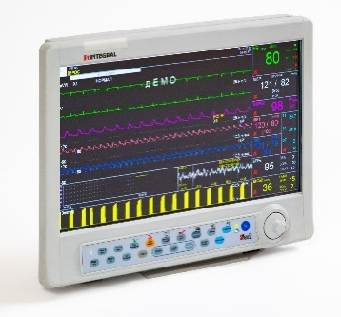 | - disposable ECG electrodes – 50 pcs;  - patient five-wire ECG cable - 1 pc;  - pulse oximetry sensors to an extension cord for adults – 1 pc;  - extension cord to a pulse oximetry sensor – 1 pc;  - reusable NIBP cuffs for adults – 2 pcs;  - extension cord for NIBP cuffs – 1 pc;  - skin temperature sensor – 1 pc. | from 2455,00
ММ-5SI patient monitor  FEACN 9018 19 900 0  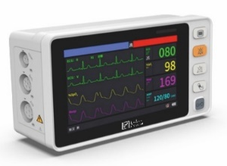 | - disposable ECG electrodes – 50 pcs;  - patient five-wire ECG cable - 1 pc;  - pulse oximetry sensors to an extension cord for adults – 1 pc;  - extension cord to a pulse oximetry sensor – 1 pc;  - reusable NIBP cuffs for adults – 2 pcs;  - extension cord for NIBP cuffs – 1 pc;  - skin temperature sensor – 1 pc. | from 555,00
ММ-12SI patient monitor  FEACN 9018 19 900 0  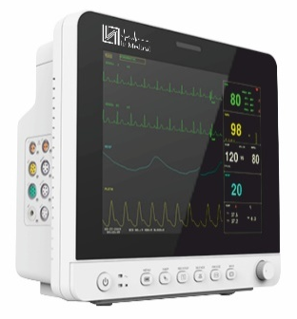 | - disposable ECG electrodes – 50 pcs;  - patient five-wire ECG cable - 1 pc;  - pulse oximetry sensors to an extension cord for adults – 1 pc;  - extension cord to a pulse oximetry sensor – 1 pc;  - reusable NIBP cuffs for adults – 2 pcs;  - extension cord for NIBP cuffs – 1 pc;  - skin temperature sensor – 1 pc. | from 585,00
ММ-15SI patient monitor  FEACN 9018 19 900 0  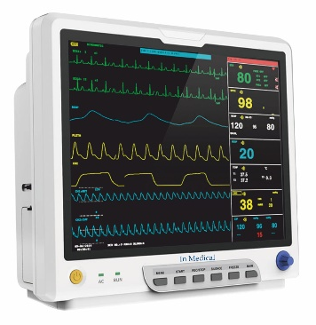 | - disposable ECG electrodes – 50 pcs;  - patient five-wire ECG cable - 1 pc;  - pulse oximetry sensors to an extension cord for adults – 1 pc;  - extension cord to a pulse oximetry sensor – 1 pc;  - reusable NIBP cuffs for adults – 2 pcs;  - extension cord for NIBP cuffs – 1 pc;  - skin temperature sensor – 1 pc. | from 635,00
ММ-16SI patient monitor  FEACN 9018 19 900 0  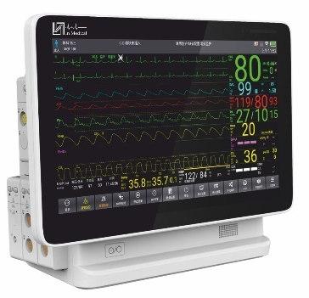 | - disposable ECG electrodes – 50 pcs;  - patient five-wire ECG cable - 1 pc;  - pulse oximetry sensors to an extension cord for adults – 1 pc;  - extension cord to a pulse oximetry sensor – 1 pc;  - reusable NIBP cuffs for adults – 2 pcs;  - extension cord for NIBP cuffs – 1 pc;  - skin temperature sensor – 1 pc. | from 1945,00
ММ-17SI patient monitor  FEACN 9018 19 900 0  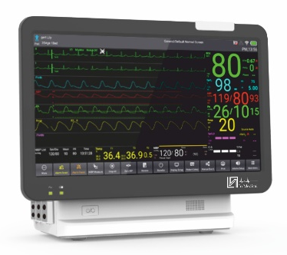 | - disposable ECG electrodes – 50 pcs;  - patient five-wire ECG cable - 1 pc;  - pulse oximetry sensors to an extension cord for adults – 1 pc;  - extension cord to a pulse oximetry sensor – 1 pc;  - reusable NIBP cuffs for adults – 2 pcs;  - extension cord for NIBP cuffs – 1 pc;  - skin temperature sensor – 1 pc. | from 2170,00
INTEGRAL KBM hospital bed (four-section)  FEACN 9402 90 000 0 | 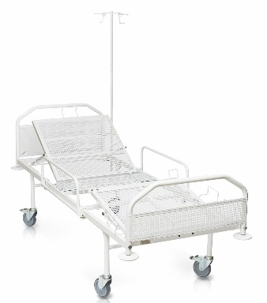  - castors – 4 pcs;  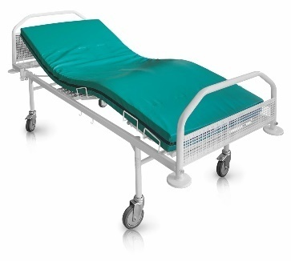  - mattress – 1 pc | from 405,00
INTEGRAL KBM-02 hospital bed (two-section)  FEACN 9402 90 000 0 | 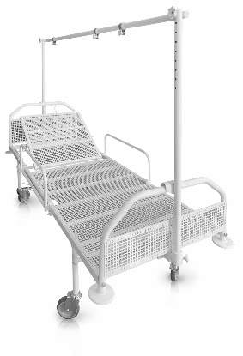  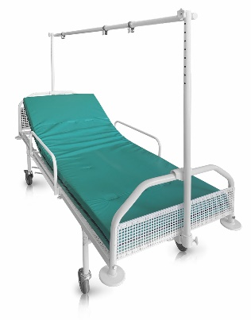  - castors – 4 pcs;  - mattress – 1 pc | from 375,00
INTEGRAL KBM-03 hospital bed (single-section)  FEACN 9402 90 000 0 | 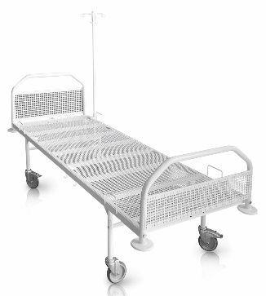  - castors – 4 pcs;  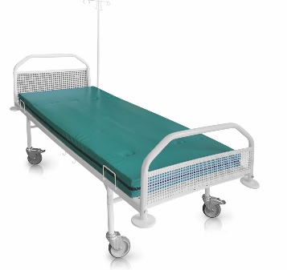  - mattress – 1 pc | from 345,00
INTEGRAL KBM-04 hospital bed (single-section) for adolescents  FEACN 9402 90 000 0 | - castors – 4 pcs;  - mattress – 1 pc | from 350,00
INTEGRAL KBE-R hospital bed (intensive care)  FEACN 9402 90 000 0 | 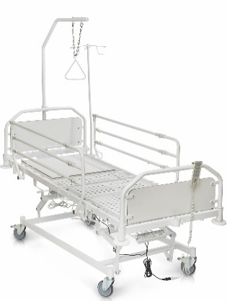  - castors – 4 pcs;  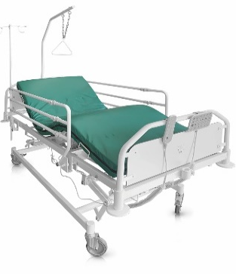  - mattress – 1 pc. | from 1310,00
INTEGRAL KBE-R hospital bed (intensive care) with central locking brake system  FEACN 9402 90 000 0 | 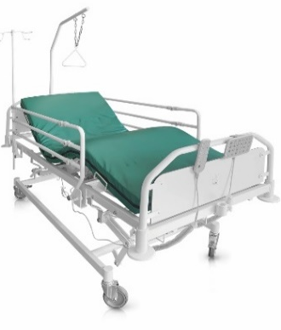  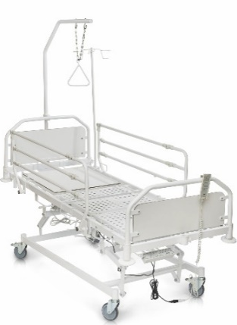  - castors – 4 pcs;  - mattress – 1 pc. | from 1965,00
MALYSHKA neonatal therapy table  FEACN 9402 90 000 0 | 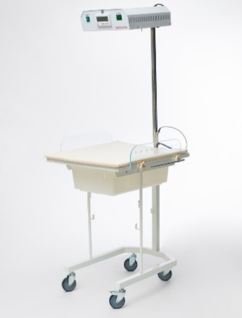 | from 329,00
Neonatal functional bed with a transparent plastic bath cuvet  FEACN 9402 90 000 0 | 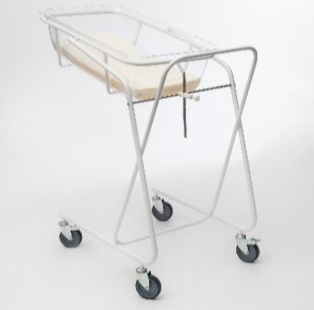 | from 225,00
IPSV-2 peak flow meters (for children)  FEACN 9018 19 9000 | 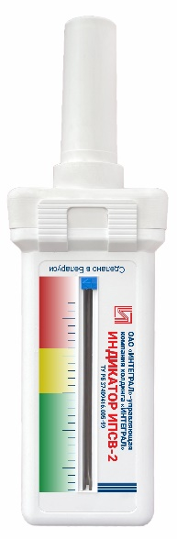 | 7,60
IPSV-1 peak flow meters (for adults)  FEACN 9018 19 9000 | 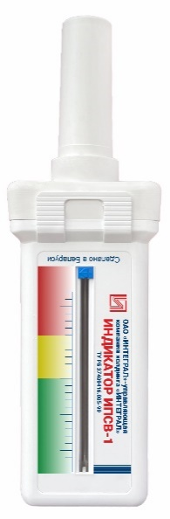 | 7,70
INTEGRAL TE-04 electronic thermometer  FEACN 9025 19 2000 | 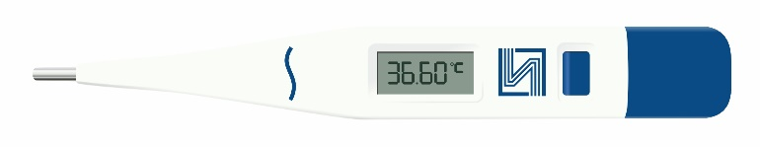 | 4,80
TI-01 infrared thermometer  FEACN 9025 19 2000 | 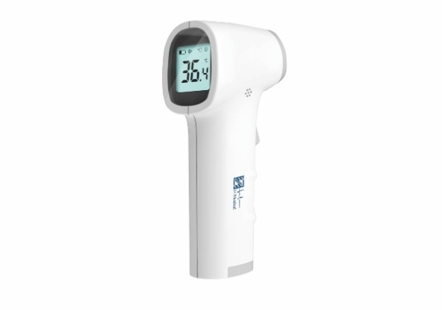 | 14,00
In Medical blood pressure meter  FEACN 9018 90 1000 | 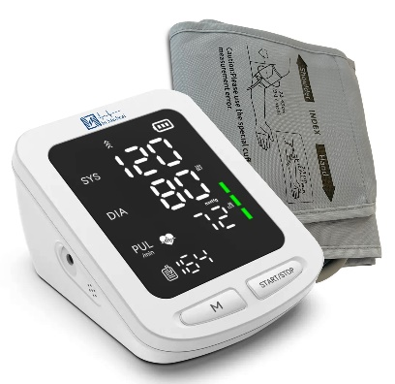 | 36,00
DFT Portable Fetal Doppler  FEACN 9018 12 0000 | 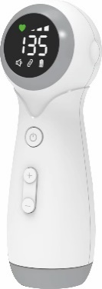 | 27,00
OBN-150K bactericidal irradiator  FEACN 9018 20 0000 | 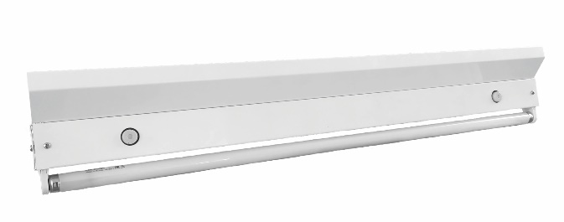 | 40,00
OBP-450K bactericidal irradiator  FEACN 9018 20 0000 | 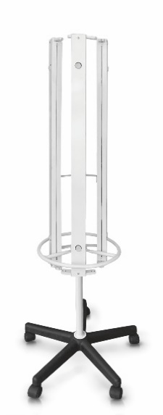 | 165,00
ORVU-75 recirculating irradiator  FEACN 9018 20 0000 | Version:  - with a counter;  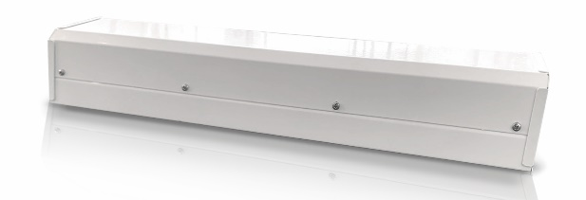  - on a stand;  - rack. | 73,50 – 105,00
ORVU-80 recirculating irradiator  FEACN 9018 20 0000 | Version:  - with a counter;  - on a stand;  - rack. | 72,00 – 100,50
ORBN-90 recirculating irradiator  FEACN 9018 20 0000 | Version:  - with a counter;  - on a stand;  - rack. | 92,00 – 113,00
ORVU-100 recirculating irradiator  FEACN 9018 20 0000 | Version:  - with a counter. | 86,00 – 90,00
Electronic stopwatches in assortment  FEACN 9102 19 000 0 | 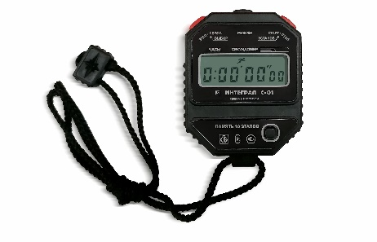 | 16,00 – 45,00
Electronic table clocks in assortment  FEACN 9102 99 000 0 | 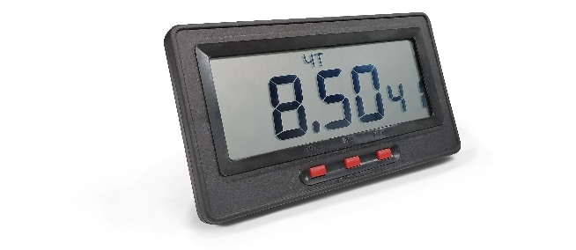 | 18,00 – 20,00
Electronic wall clocks  in assortment  FEACN 9105 21 000 0 | 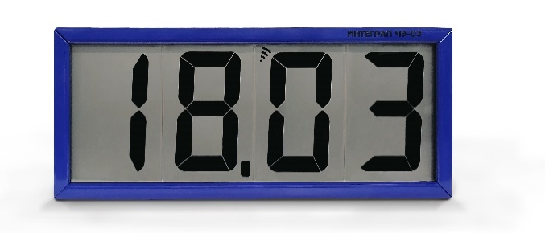 | 124,00 – 276,00
Electronic wall calendar clocks  in assortment  FEACN 9105 21 000 0 | 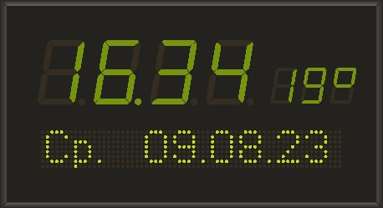 | 820,00 – 1 080,00

